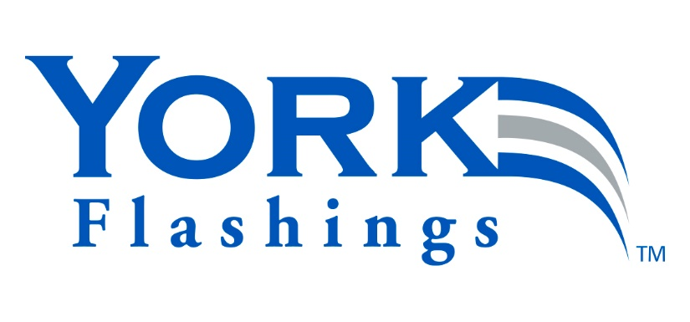
GUIDE SPECIFICATION
SECTION 07 6526.13
SELF-ADHERING STAINLESS STEEL SHEET MEMBRANE

NOTES TO SPECIFIER:
This guide specification is provided in a user-friendly format for use in your specification, courtesy of York Manufacturing, Inc. It is written in compliance with CSI MasterFormat® and CSI SectionFormat® for compatibility with most specifications in use in our industry. If your preferred format is different, we welcome you to modify this content to best suit your practice standards.
This specification as presented, is intended to be used as Section 07 6526.13 for those circumstances in which this product may be used in more than one application associated with other masonry, weather barrier, and/or waterproofing work results. In that case, this Section should be referenced under the Division 01 Article “RELATED SECTIONS” in each of those specification Sections.
Selected portions of the content of this guide specification can also be inserted into specific masonry, weather barrier, and/or waterproofing specification Sections as an accessory component; some typical applications may include:
DIVISION 04 - MASONRY
Section 04 2000 – Unit Masonry
Section 04 2113.13 – Brick Veneer Masonry
Section 04 2200 – Concrete Unit Masonry
Section 04 2613 – Masonry Veneer

DIVISION 07 – THERMAL AND MOISTURE PROTECTION
Section 07 1000 – Dampproofing and Waterproofing
Section 07 1300 – Sheet Waterproofing
Section 07 1400 – Fluid-Applied Waterproofing
Section 07 2500 – Weather Barriers
Section 07 2700 – Air Barriers
Section 07 2716 – Sheet Metal Membrane Air Barriers

